**“Experiment – 10”**

Name: **SUMIT KUMAR** UID: **20BCS8226**

Branch: **BE-CSE** Section/Group: **MM 808 A**

Semester: **5th** Date of Submission: **10/11/22**

Subject Name: **Machine Learning Lab** Subject Code: **20CSP-317**

**1. Aim/Overview of the practical:**

Implement Association Rule Mining.

**2. Task to be done/ Which logistics used:**

To implement Association Rule Mining.

**3. Steps for experiment/practical/Code:**

  ['T100',['I1','I2','I5']],

        ['T200',['I2','I4']],

        ['T300',['I2','I3']],

        ['T400',['I1','I2','I4']],

        ['T500',['I1','I3']],

        ['T600',['I2','I3']],

        ['T700',['I1','I3']],

        ['T800',['I1','I2','I3','I5']],

        ['T900',['I1','I2','I3']]

        ]

init = []

for i in data:

    for q in i[1]:

        if(q not in init):

            init.append(q)

init = sorted(init)

print(init)

sp = 0.4

s = int(sp*len(init))

s

from collections import Counter

c = Counter()

for i in init:

    for d in data:

        if(i in d[1]):

            c[i]+=1

print("C1:")

for i in c:

    print(str([i])+": "+str(c[i]))

print()

l = Counter()

for i in c:

    if(c[i] >= s):

        l[frozenset([i])]+=c[i]

print("L1:")

for i in l:

    print(str(list(i))+": "+str(l[i]))

print()

pl = l

pos = 1

for count in range (2,1000):

    nc = set()

    temp = list(l)

    for i in range(0,len(temp)):

        for j in range(i+1,len(temp)):

            t = temp[i].union(temp[j])

            if(len(t) == count):

                nc.add(temp[i].union(temp[j]))

    nc = list(nc)

    c = Counter()

    for i in nc:

        c[i] = 0

        for q in data:

            temp = set(q[1])

            if(i.issubset(temp)):

                c[i]+=1

    print("C"+str(count)+":")

    for i in c:

        print(str(list(i))+": "+str(c[i]))

    print()

    l = Counter()

    for i in c:

        if(c[i] >= s):

            l[i]+=c[i]

    print("L"+str(count)+":")

    for i in l:

        print(str(list(i))+": "+str(l[i]))

    print()

    if(len(l) == 0):

        break

    pl = l

    pos = count

print("Result: ")

print("L"+str(pos)+":")

for i in pl:

    print(str(list(i))+": "+str(pl[i]))

print()

from itertools import combinations

for l in pl:

    c = [frozenset(q) for q in combinations(l,len(l)-1)]

    mmax = 0

    for a in c:

        b = l-a

        ab = l

        sab = 0

        sa = 0

        sb = 0

        for q in data:

            temp = set(q[1])

            if(a.issubset(temp)):

                sa+=1

            if(b.issubset(temp)):

                sb+=1

            if(ab.issubset(temp)):

                sab+=1

        temp = sab/sa*100

        if(temp > mmax):

            mmax = temp

        temp = sab/sb*100

        if(temp > mmax):

            mmax = temp

        print(str(list(a))+" -> "+str(list(b))+" = "+str(sab/sa*100)+"%")

        print(str(list(b))+" -> "+str(list(a))+" = "+str(sab/sb*100)+"%")

    curr = 1

    print("choosing:", end=' ')

    for a in c:

        b = l-a

        ab = l

        sab = 0

        sa = 0

        sb = 0

        for q in data:

            temp = set(q[1])

            if(a.issubset(temp)):

                sa+=1

            if(b.issubset(temp)):

                sb+=1

            if(ab.issubset(temp)):

                sab+=1

        temp = sab/sa*100

        if(temp == mmax):

            print(curr, end = ' ')

        curr += 1

        temp = sab/sb*100

        if(temp == mmax):

            print(curr, end = ' ')

        curr += 1

    print()

    print()

**4. Result/Output/Writing Summary:**

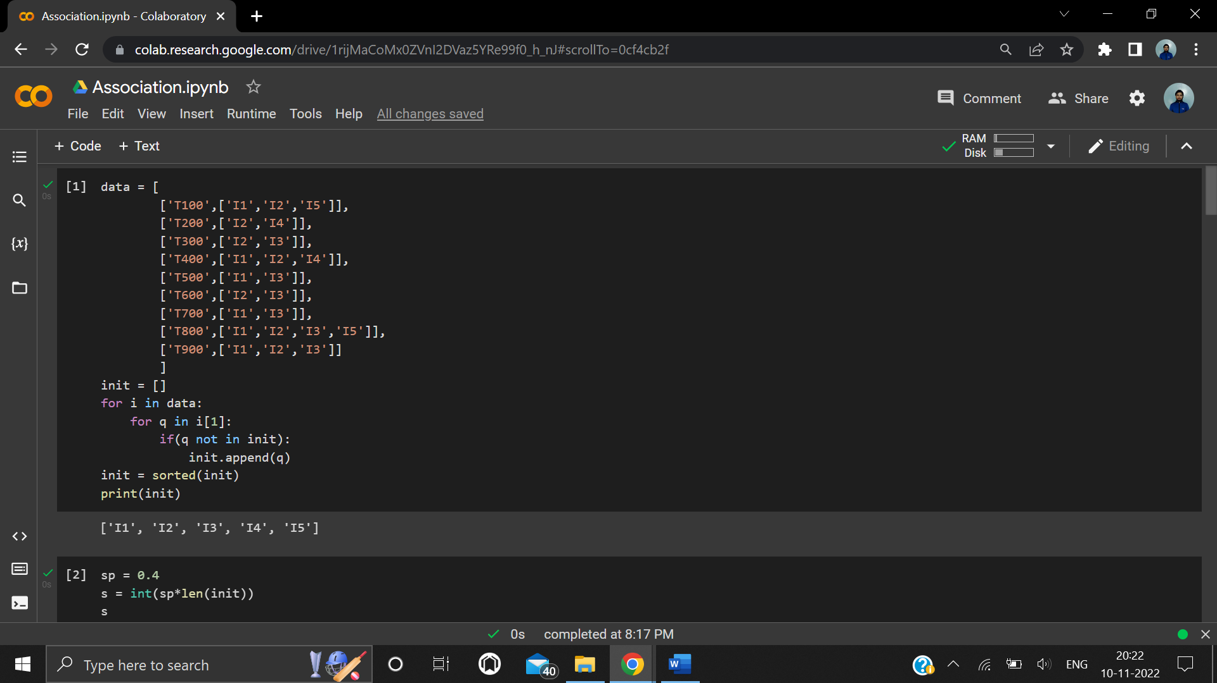

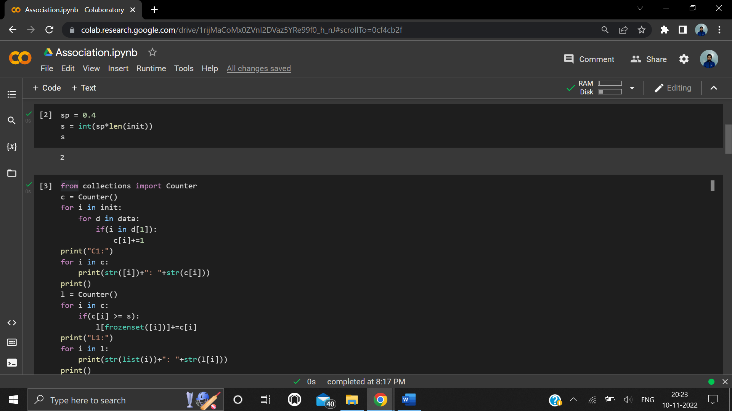

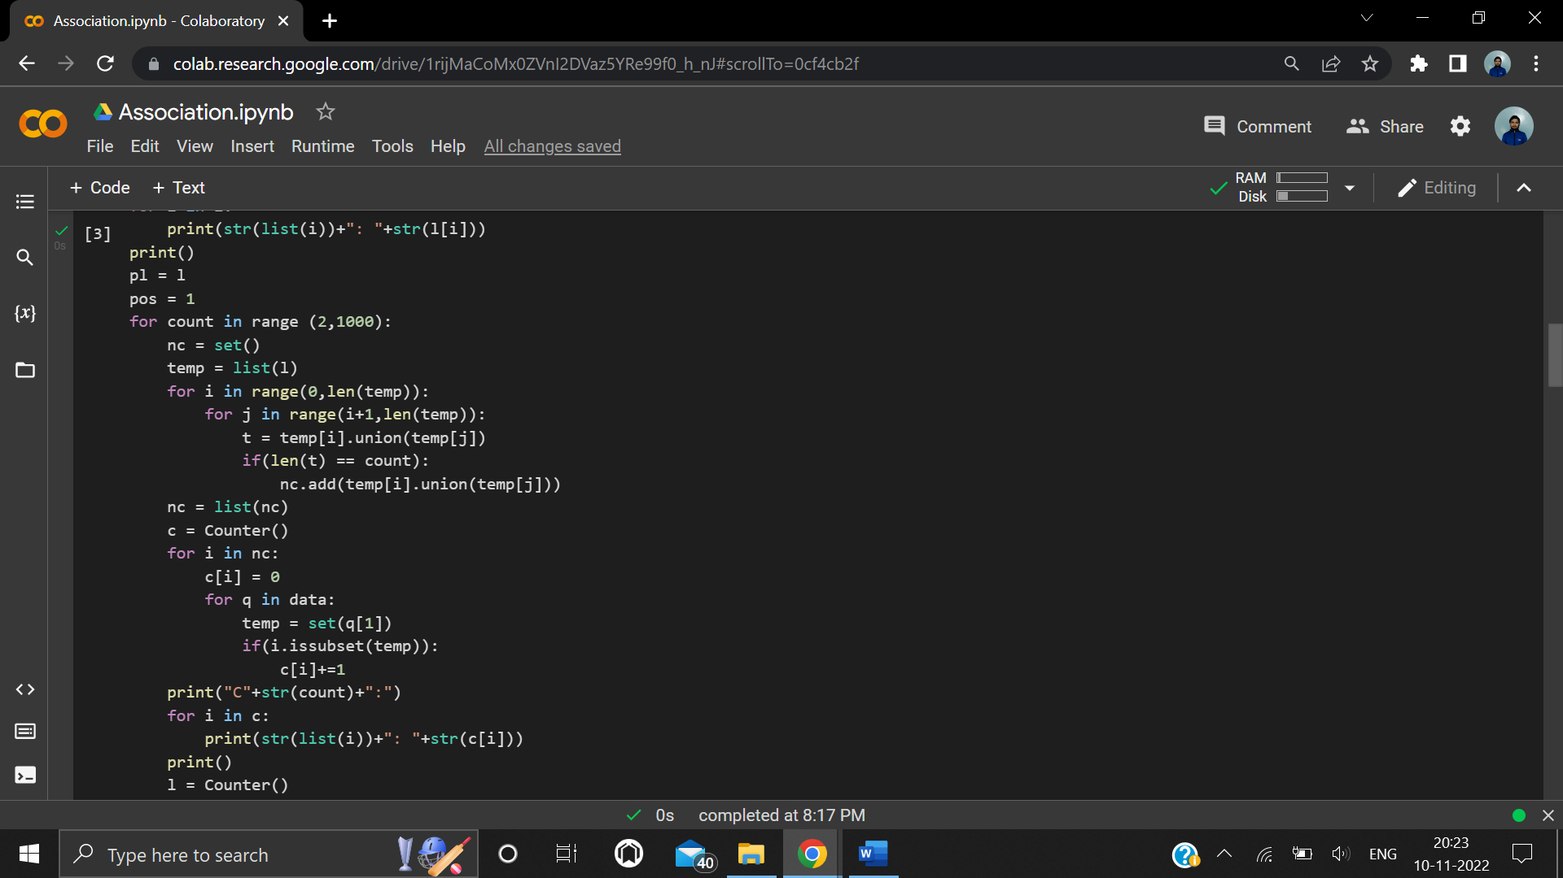

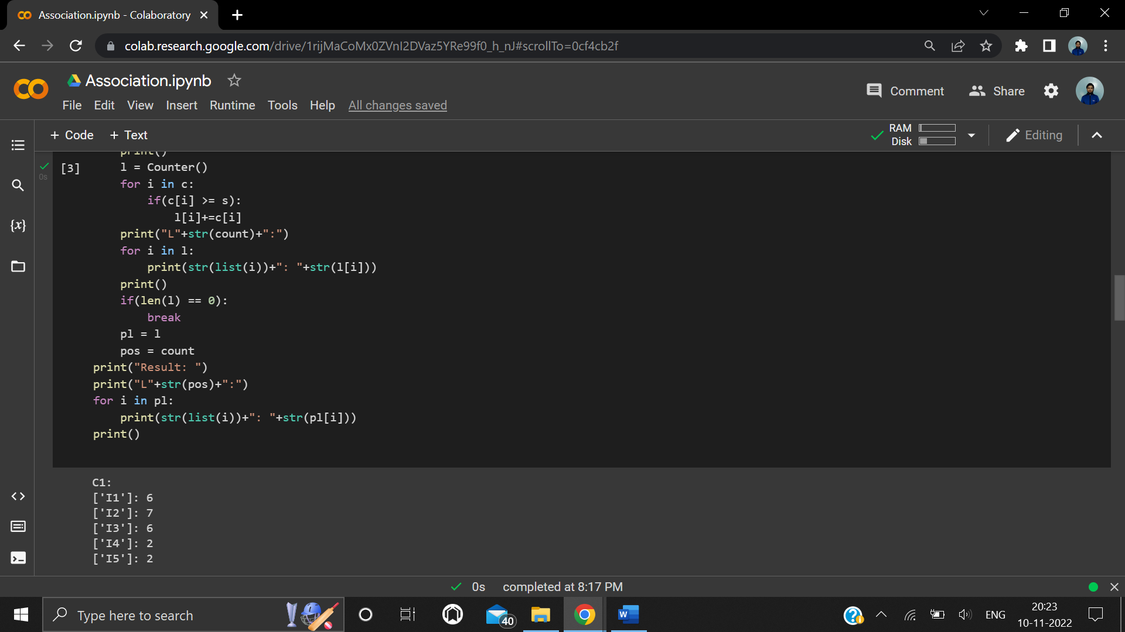

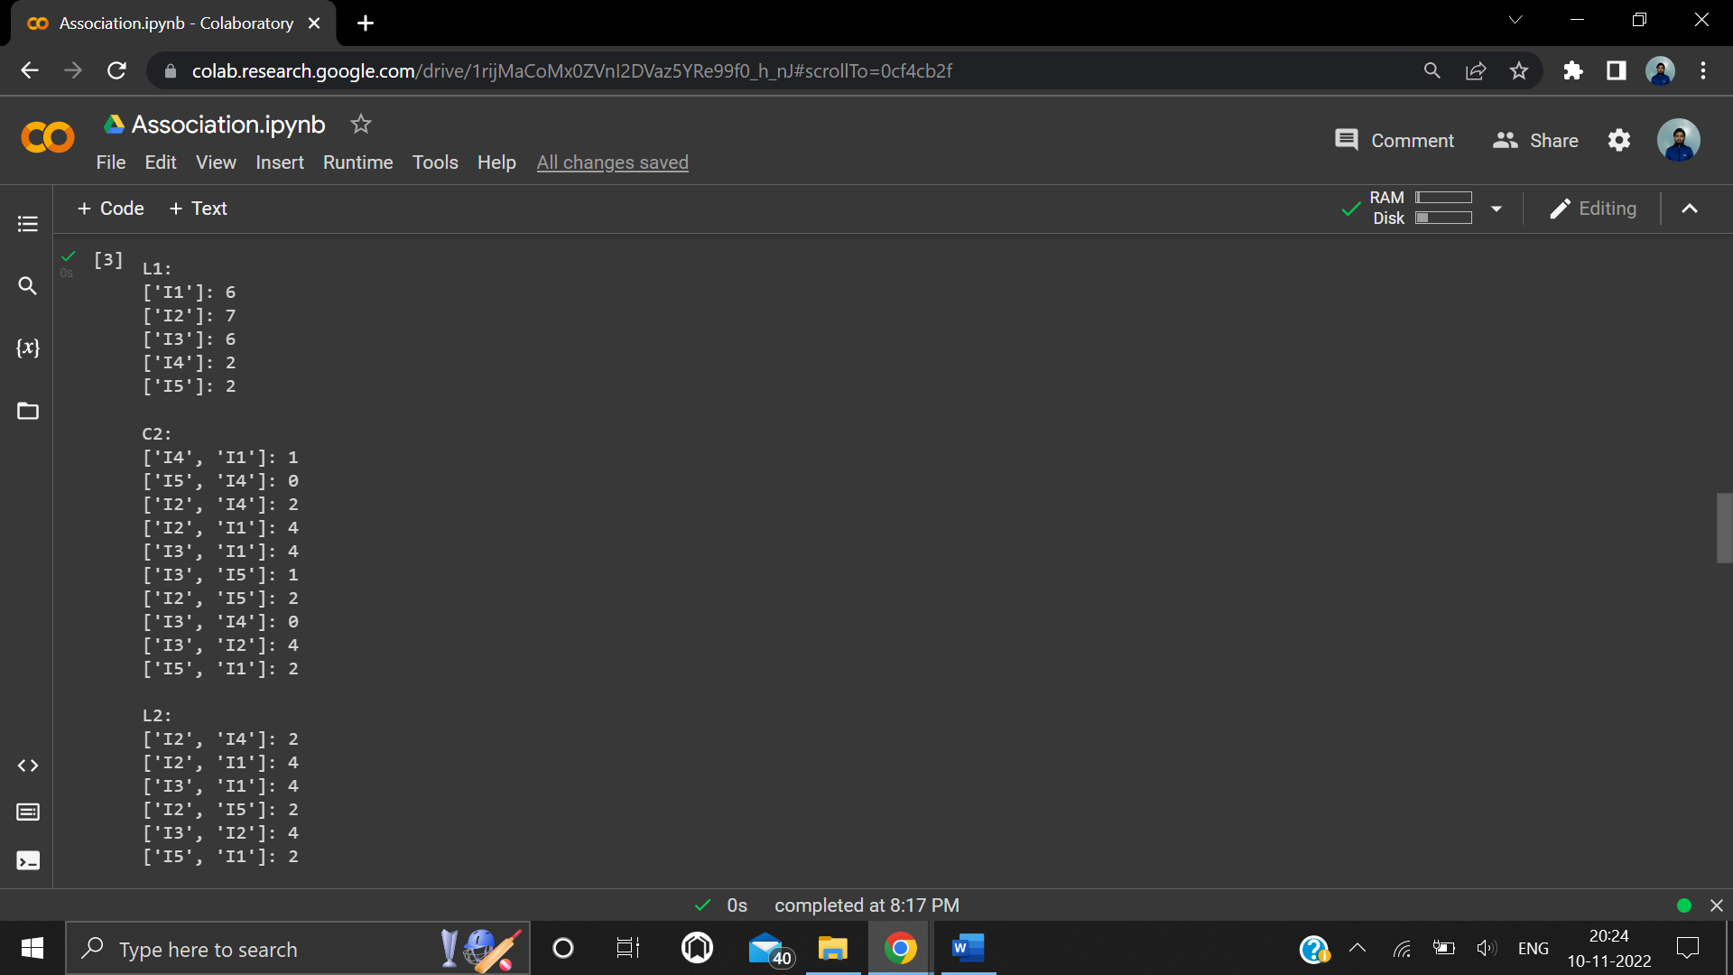

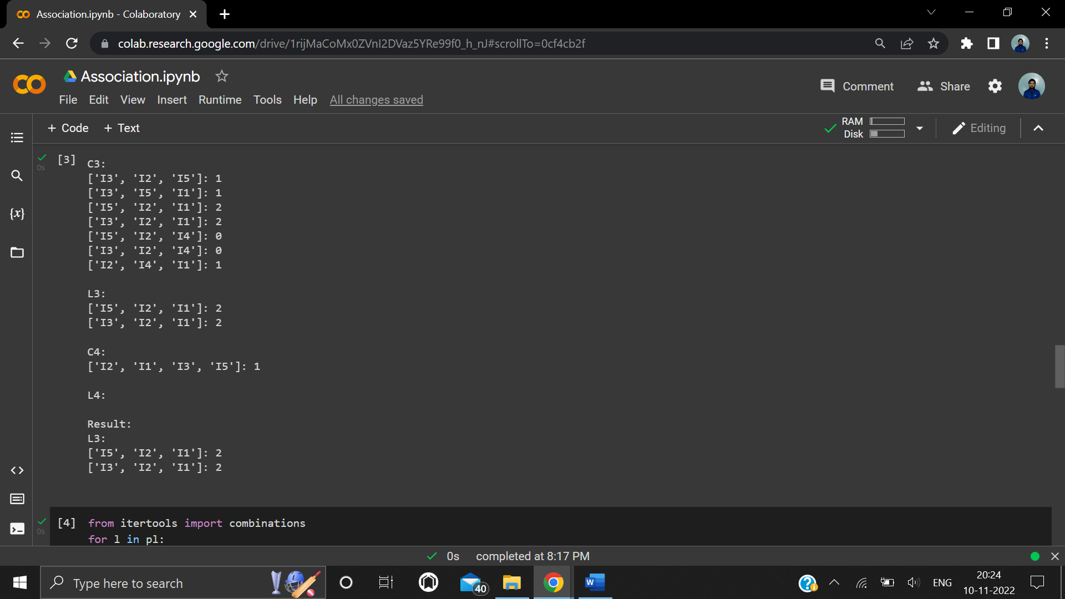

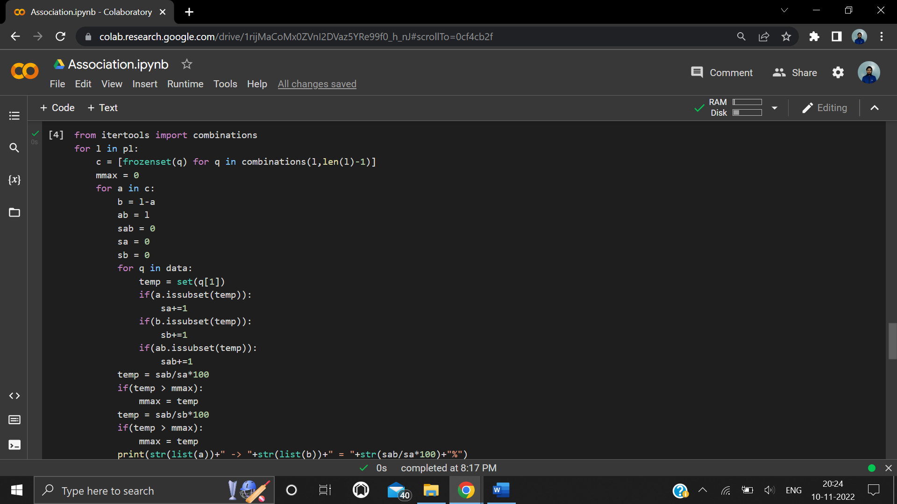

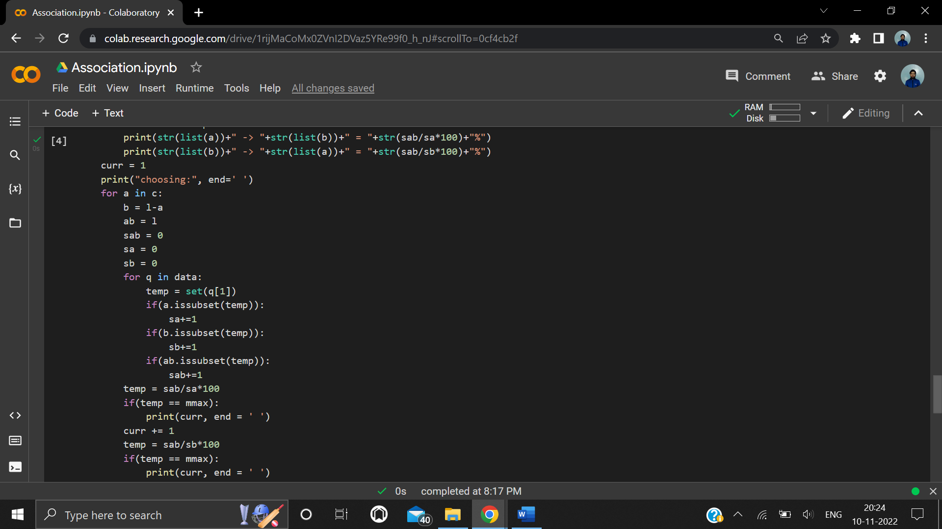

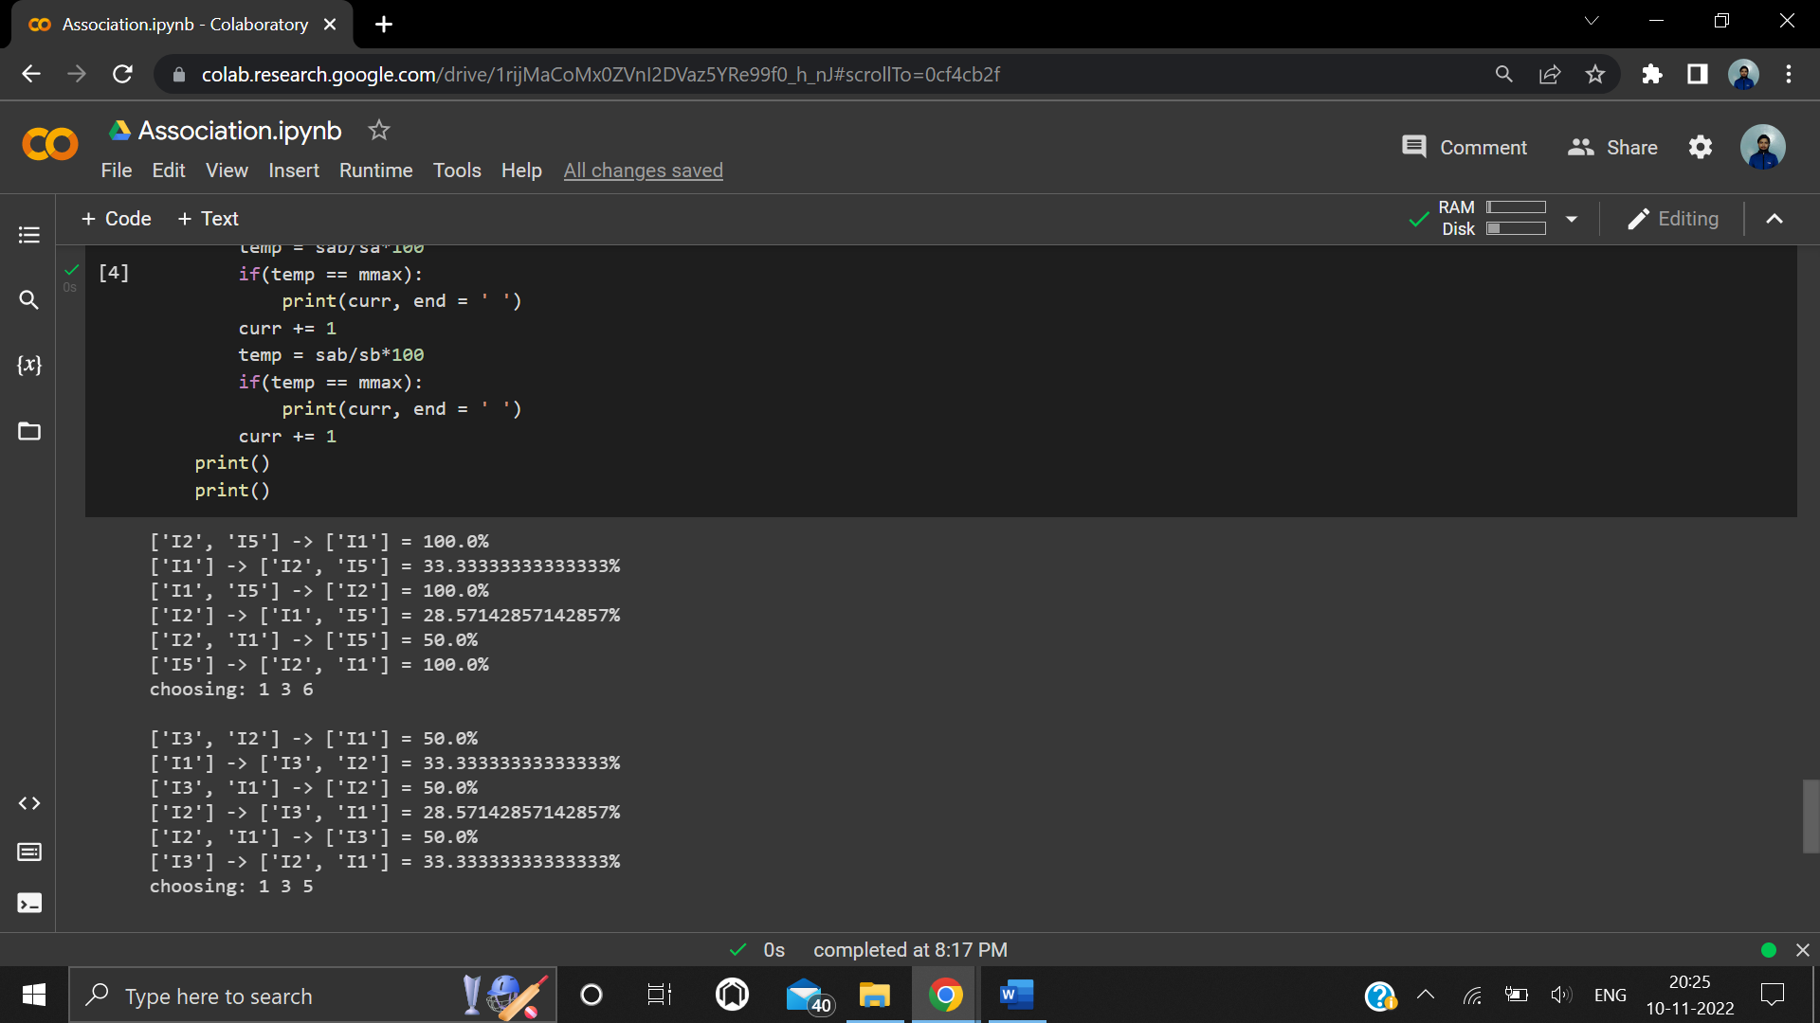

**Learning outcomes (What I have learnt):**

1. Understood the concept of ARM.
2. Learnt how to do association.
3. Learnt the practical aspects of ARM.
4. Learnt in detail about Association Rule Mining.

**Evaluation Grid (To be created as per the SOP and Assessment guidelines by the faculty):**

|  |  |  |  |
| --- | --- | --- | --- |
| Sr. No. | Parameters | Marks Obtained | Maximum Marks |
| 1. |  |  |  |
| 2. |  |  |  |
| 3. |  |  |  |
|  |  |  |  |